**POINT PROCESSING**

**Code**

% Original Image

a=imread('drag.jpg');

figure(1);

% Grayscale Image

imshow(a);

b=rgb2gray(a);

figure(2);

imshow(b);

% Negation

c = 255.-b;

figure(3);

imshow(c);

[m,n] = size(b);

% Thresholding

d = b;

t = input('Enter the threshold value: ');

for i = 1:m

for j = 1:n

if b(i,j)>=t

d(i,j) = 255;

else

d(i,j) = 0;

end

end

end

figure(4);

imshow(d);

% Grayscale Slicing

lower = input('Enter the lower limit of the range: ');

upper = input('Enter the upper limit of the range: ');

% Without background

e=b;

for i = 1:m

for j = 1:n

if b(i,j)>=lower && b(i,j)<=upper

e(i,j) = 255;

else

e(i,j) = 0;

end

end

end

figure(5);

imshow(e);

% With background

f=b;

for i = 1:m

for j = 1:n

if b(i,j)>=lower && b(i,j)<=upper

f(i,j) = 255;

end

end

end

figure(6);

imshow(f);

% Bit Plane slicing

g=b;

[m,n]=size(g);

count='1';

for k = 1:8

h=g;

figure(7);

for i = 1:m

for j = 1:n

h(i,j) = mod(g(i,j),2);

g(i,j) = (g(i,j)-h(i,j))/2;

if(h(i,j)==1)

h(i,j)=255;

end

end

end

subplot(2,4,k),imshow(h);

if(count=='1')

title('Bit-8(LSB)');

elseif(count=='8')

title('Bit-1(MSB)');

else

title(strcat('Bit-',count)); % strcat for concatenating 2 strings

end

count = count + 1;

end

**Output**

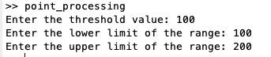

1. **Original Image**

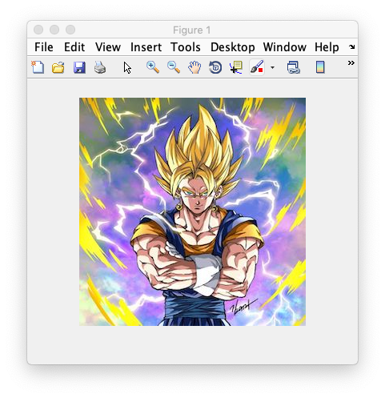

1. **Grayscale Image**

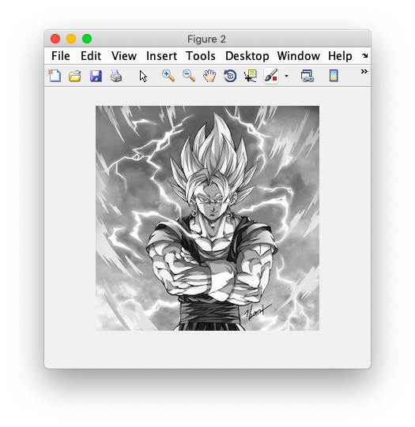

1. **Negation**

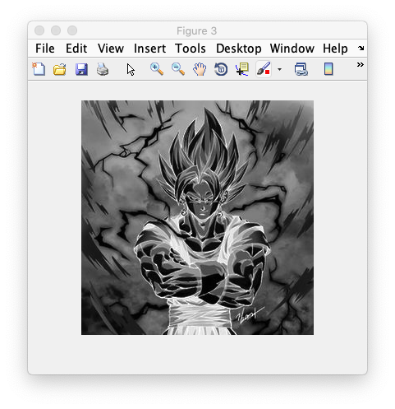

1. **Thresholding (T=100)**

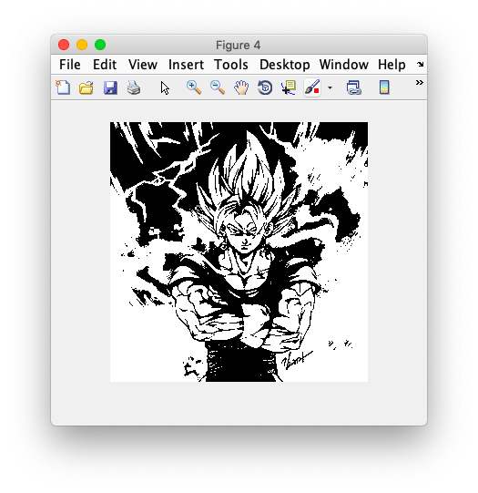

1. **Grayscale Slicing (without background) (Range: 100 to 200)**

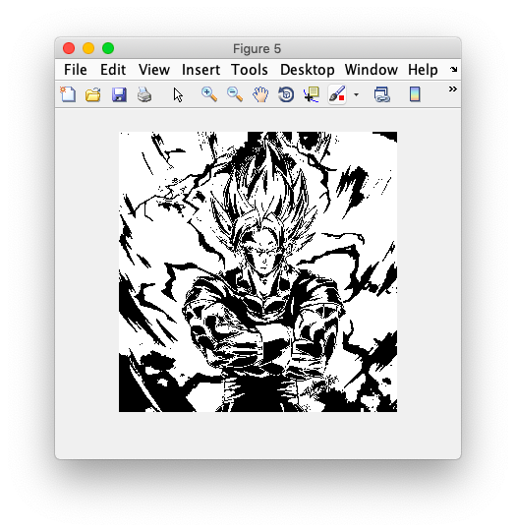

1. **Grayscale Slicing (with background) (Range: 100 to 200)**

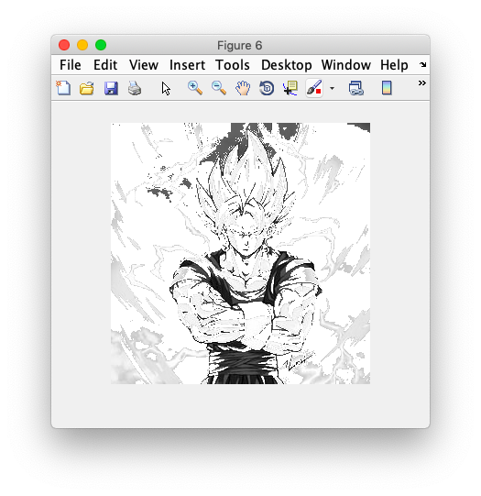

1. **Bit Plane Slicing (LSB to MSB)**

